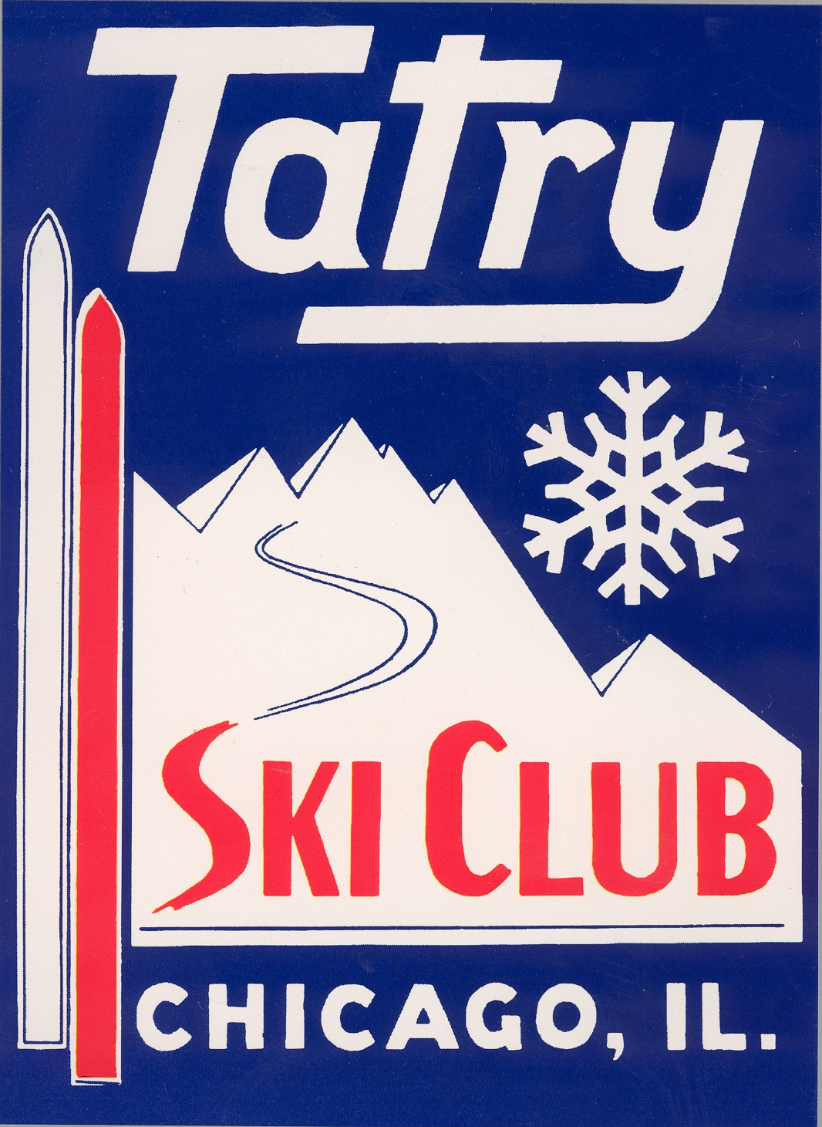 **ADVERTISING CONTRACT**

**XXV International Polish Championship**

**In**

**Alpine Skiing and Snowboarding**

**Breckenridge, Colorado**

**March 18-21, 2025**

**PLEASE CHOOSE FROM AVAILABLE FORMS OF ADVERTISEMENTS**

**______ Full Package ($1000) (graphics due by March 12th)**

Includes:

* Production of 4 ft x 3 ft (l x h) full color banner, according to received graphics.
* Displaying above banner:
  + In the finish area during competition, 9am to 3pm, March 20-21
  + During registration, 5pm to 8pm, March 18-19
  + During Awards Banquet, 6pm-11pm, March 21
* Displaying full color advertisement in booklets on the Awards Banquet tables
* Displaying full color advertisement on the TV during Avards Banquet

**______ Half Package ($500) (graphics due by March 12th)**

Includes:

* Displaying full color advertisement in booklet on the Awards Banquet tables
* Displaying full color advertisement on the TV during Avards Banquet

**______ Basic Package ($250) (graphics due by March 17th)**

Includes:

* Displaying full color advertisement on the TV during Avards Banquet

**MAKE ALL CHECKS PAYABLE TO: TATRY SKI CLUB**

Mailing address: 7341 Banks Street Justice, IL 60458

Please email graphics of your AD to the following email address: piotrm123@gmail.com

If you have any questions, please call: Piotr Madrzyk (630) 240-6926

Business name: __________________________________

Telephone: _________________________________________

Ad authorized by: ________________________________